Dear Patient,

Welcome to Idaho Physical Medicine & Rehabilitation (IPM&R)!

Please complete the following paperwork to the best of your knowledge.
Bring the completed paperwork with you to your appointment, as well as your photo ID, your insurance card(s), applicable imaging reports/records, and a list of any medications you are taking.

Should you have any questions or concerns, please contact the office at
(208) 884-1333.

You must arrive 30 minutes before your appointment

Arriving late, or with incomplete paperwork could result in your appointment being rescheduled.

We look forward to seeing you soon!

Thank you,

Idaho Physical Medicine and Rehabilitation

DIRECTIONS TO BOISE OFFICE: 161 E. Mallard Dr. Ste. 120

TAKING CITY CENTER EXIT OFF OF I-84
Follow signs for Interstate I-184 City Center/Myrtle (3.5 mi)
I-184 becomes Myrtle (2.1 mi)
Continue straight, passing Broadway Ave, Myrtle becomes E Park Blvd (.3)
Use the Right 3 lanes to turn slightly Right onto W Parkcenter Blvd (.9 mi)
Turn Right on E Mallard Dr (.2 mi)
Destination will be on the Left

TAKING I-84 FROM EAST OR WEST
Take the Broadway Exit
Follow Broadway and take a Right onto Beacon St (2.3 mi)
Turn Right onto W Parkcenter Blvd (.3 mi)
Turn Right onto E Mallard Dr (.5 mi)
Destination will be on the Left (.2 mi)

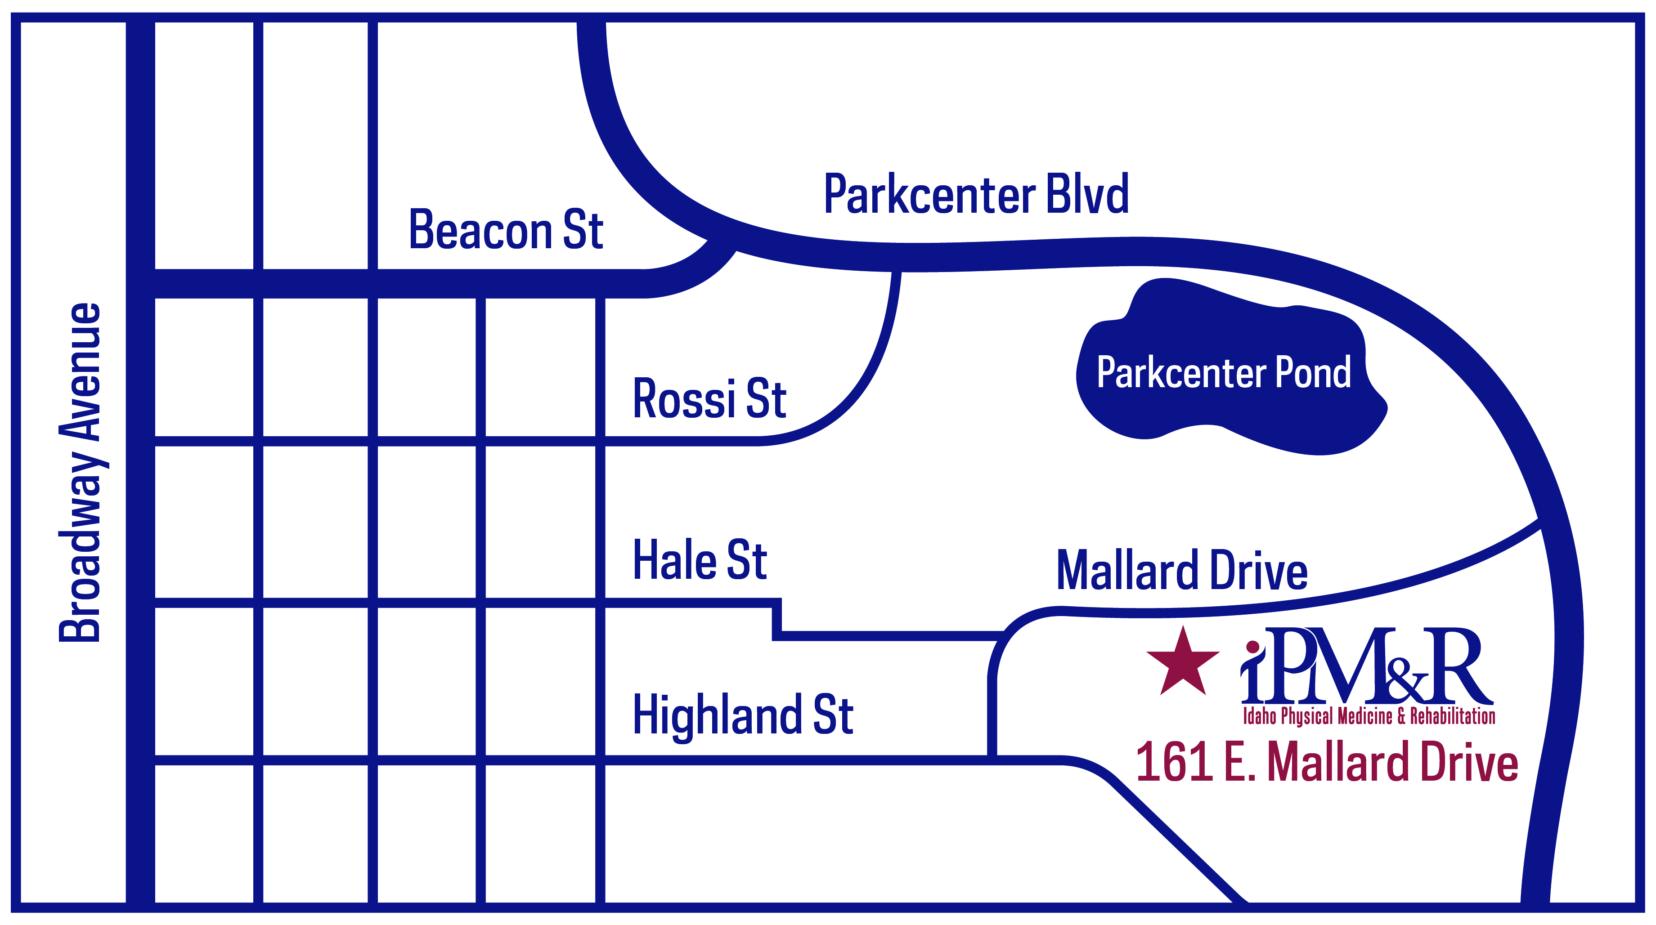

To Idaho Physical Medicine and Rehabilitation (IPMR): Once you enter the building, our office is on the right, suite 120.

Idaho Physical Medicine and Rehabilitation, PA

REGISTRATION FORM
Today’s date: |  |  |  |  |  |  |  |  |  |  |  |  |  |  |  |  |  |  |  |  |  |  |  |  |  |  |  |  | Primary Care Provider:

PATIENT INFORMATION
Patient’s last name: |  |  |  |  |  |  |  |  |  |  |  |  |  |  |  |  |  | First: |  |  |  |  |  |  |  |  |  | Middle: | q Mr.  q Mrs. |  |  |  | q Miss  q Ms. |  |  |  |  |  |  |  | Marital status (circle one)
 |  |  |  |  |  |  |  |  |  |  |  |  |  |  |  |  |  |  |  |  |  |  |  |  |  |  |  |  |  |  |  |  |  |  |  |  |  |  |  |  | Single / Mar / Div / Sep / Wid
Is this your legal name? |  |  |  |  | If not, what is your legal name? |  |  |  |  |  |  |  |  |  |  |  |  |  |  |  |  |  |  | (Former name): |  |  |  |  |  |  |  |  |  |  |  |  | Birth date: |  |  |  |  |  |  |  | Age: |  |  | Sex:
q Yes |  | q No |  |  |  |  |  |  |  |  |  |  |  |  |  |  |  |  |  |  |  |  |  |  |  |  |  |  |  |  |  |  |  |  |  |  | / / |  |  |  |  |  |  |  |  |  |  | q M |  |  | q F
Ethnicity: |  | q Hispanic or Latino q Not Hispanic or Latino |  |  |  |  |  |  |  |  |  |  |  |  |  |  |  |  |  |  |  |  |  | Preferred Language: Email address:
Race: |  | q American Indian or Alaska Native q Asian q Native Hawaiian q African American q White q Hispanic q Other
Street address: |  |  |  |  |  |  |  |  |  |  |  |  |  |  |  |  |  |  |  |  |  |  |  |  |  |  | Social Security #: |  |  |  |  |  |  |  |  |  |  |  |  |  | Home phone #:
 |  |  |  |  |  |  |  |  |  |  |  |  |  |  |  |  |  |  |  |  |  |  |  |  |  |  |  |  |  |  |  |  |  |  |  |  |  |  |  |  | Cell Phone#:
P.O. Box: |  |  |  |  |  |  |  |  |  | City: |  |  |  |  |  |  |  |  |  |  |  |  |  |  |  |  |  |  |  |  | State: |  |  |  |  |  |  |  |  |  |  |  |  | ZIP Code:
Occupation: |  |  |  |  |  |  |  |  |  | Employer: |  |  |  |  |  |  |  |  |  |  |  |  |  |  |  |  |  |  |  |  |  |  |  |  |  |  |  |  |  | Work phone #:
 |  |  |  |  |  |  |  |  |  |  |  |  |  |  |  |  |  |  |  |  |  |  |  |  |  |  |  |  |  |  |  |  |  |  |  |  |  |  |  | ( )
Chose clinic because/Referred to clinic by (please check one box): |  |  |  |  |  |  |  |  |  |  |  |  |  |  |  |  |  |  |  |  |  |  |  |  |  |  |  | q Dr. |  |  |  |  |  |  |  |  |  |  |  |  |  | q Insurance Plan |  |  |  |  |  |  |  | q Hospital
q Family |  |  | q Friend |  |  | q Close to home/work |  |  |  |  |  |  |  |  |  |  |  |  |  |  |  |  | q Yellow Pages |  |  |  |  |  |  |  | q Other
Pharmacy |  |  |  |  |  |  |  |  |  |  | Address/Ph#

INSURANCE INFORMATION
(Please give your insurance card to the receptionist.)
Person responsible for bill: |  |  |  |  |  |  | Birth date: |  |  |  |  |  |  |  |  |  |  |  |  |  | Address (if different): |  |  |  |  |  |  |  |  |  |  |  |  |  |  |  |  |  |  | Home phone #:
 |  |  |  |  |  |  | / / |  |  |  |  |  |  |  |  |  |  |  |  |  |  |  |  |  |  |  |  |  |  |  |  |  |  |  |  |  |  |  |  | ( )
Is this person a patient here? |  |  |  |  |  |  | q Yes |  |  |  |  |  |  |  |  | q No
Occupation: |  |  |  | Employer: |  |  |  |  |  |  |  |  |  |  | Employer address: |  |  |  |  |  |  |  |  |  |  |  |  |  |  |  |  |  |  |  |  |  |  |  |  | Employer phone #:
 |  |  |  |  |  |  |  |  |  |  |  |  |  |  |  |  |  |  |  |  |  |  |  |  |  |  |  |  |  |  |  |  |  |  |  |  |  |  |  | ( )
Is this patient covered by insurance? |  |  |  |  |  |  |  |  |  |  |  | q Yes |  |  |  |  |  |  |  | q No
Please indicate primary insurance |  |  |  |  |  |  |  |  | q [Insurance] |  |  |  |  |  |  |  |  |  |  |  |  |  |  |  |  |  |  |  |  | q Medicaid # |  |  |  |  |  |  |  |  |  |  |  |  |  |  |  |  | q Other
q Is injury from a motor vehicle accident? |  |  |  |  |  |  |  | q Yes q No |  |  |  |  |  |  |  |  |  |  |  |  |  |  |  | q Injury WORK COMP related? |  |  |  |  |  |  |  |  |  |  |  |  |  |  | q Yes q No
Subscriber’s name: |  |  |  |  |  |  |  |  | Subscriber’s #: |  |  |  |  |  |  |  |  |  |  |  |  |  |  |  | Birth date: |  |  |  | Group #: |  |  |  |  |  |  |  |  |  |  | Policy #: |  |  |  |  |  |  |  |  | Co-payment:
 |  |  |  |  |  |  |  |  |  |  |  |  |  |  |  |  |  |  |  |  |  |  |  |  | / / |  |  |  |  |  |  |  |  |  |  |  |  |  |  |  |  |  |  |  |  |  |  |  | $
Patient’s relationship to subscriber: |  |  |  |  |  |  |  |  |  |  |  |  | q Self |  |  |  |  |  |  |  |  | q Spouse |  |  |  |  |  | q Child | q Other
Name of secondary insurance (if applicable): |  |  |  |  |  |  |  |  |  |  |  |  |  |  |  |  |  |  | Subscriber’s name: |  |  |  |  |  |  |  |  |  |  |  |  |  |  |  | Group no.: |  |  |  |  |  |  |  |  |  |  | Policy no.:
Patient’s relationship to subscriber: |  |  |  |  |  |  |  |  |  |  |  |  |  | q Self |  |  |  |  |  |  |  | q Spouse |  |  |  |  |  | q Child | q Other

IN CASE OF EMERGENCY
Name of local friend or relative: |  |  |  |  |  |  |  |  |  |  |  |  |  |  |  |  |  |  |  |  |  |  |  |  |  | Relationship to patient: |  |  |  |  |  |  |  | Home phone #: |  |  |  |  |  |  |  |  |  |  | Alternate phone #:
 |  |  |  |  |  |  |  |  |  |  |  |  |  |  |  |  |  |  |  |  |  |  |  |  |  |  |  |  |  |  |  |  |  | ( ) |  |  |  |  |  |  |  |  |  |  | ( )
The above information is true to the best of my knowledge. I authorize my insurance benefits be paid directly to the physician. I understand that I am financially responsible for any balance. I also authorize Idaho PMR or insurance company to release any information required to process my claims.
 | Patient/Guardian signature |  |  |  |  |  |  |  |  |  |  |  |  |  |  |  |  |  |  |  |  |  |  |  |  |  |  |  |  |  |  |  |  |  |  | Date

IDAHO PHYSICAL MEDICINE AND REHABILITATION, PA
CONSENT AND CONDITIONS OF TREATMENT

CONSENT FOR TREATMENT. I voluntarily consent to care and treatment of the Patient by Idaho Physical Medicine and Rehabilitation, P.A. (“IPM&R”) and its affiliated physicians, practitioners, and staff, including but not limited to outpatient medical, surgical, nursing, and therapeutic care; diagnostic, laboratory, and radiological tests and procedures; administration of pharmaceuticals or anesthesia; and such other care as deemed reasonably necessary or advisable by the attending physician, practitioner or staff member. If IPM&R personnel suffer a needle stick or are exposed to blood or body fluids, I consent to the testing of Patient for any blood-borne disease for the protection of IPM&R personnel.

ADVANCE DIRECTIVES (APPLIES ONLY TO PATIENTS RECEIVING TREATMENT IN THE IPMR AMBULATORY SURGERY CENTER (ASC))
Please indicate whether the Patient has executed an advance directive, e.g.:
[ ] Living Will [ ] Durable Power of Attorney [ ] POST [ ] Other (describe): ________________________
I understand that it is IPM&R’s Ambulatory Surgery Center policy not to comply with advance directives that would prohibit life sustaining treatment. I consent to such treatment on behalf of the Patient, and agree that any contrary directions in the Patient’s advance directives shall be suspended while the patient receives care at IPM&R Ambulatory Surgery Center.

CONDITIONS FOR TREATMENT AT IPM&R. In consideration for the care and treatment that Patient will receive or has received at IPM&R, I agree to the following:

1. Patient Responsibilities. I agree to comply with the Patient Responsibilities set forth in IPM&R’s separate Notice of Policies, Patient Rights, and Patient Responsibilities.

2. Payment. I agree that I am responsible for any co-payments, deductibles or other charges for services to Patient that are not paid by insurance, government programs, or other payers, except as prohibited by applicable law or any agreement between my insurance company and IPM&R. I agree to make such payments according to IPM&R’s regular terms of payment. Where appropriate, I agree to submit and cooperate with IPM&R in submitting claims to entities from which payment may be obtained, including any government program, insurance company, or other third parties. I understand that I will remain responsible for any amount not paid by insurance or a third party. If the Patient’s account becomes delinquent, I agree to pay interest and fees according to IPM&R’s policies, including but not limited to reasonable costs of collection, collection agency fees, attorneys fees, and court costs. I agree that any overpayments collected for Patient’s admission or treatment on this occasion may be applied directly to any delinquent account of Patient.

3. Assignment. I hereby assign and authorize direct payment to IPM&R of any payments or other benefits to which I or the Patient may be entitled from any government program, insurance company, or other entity that is or may be liable for costs associated with Patient’s care. I agree that this assignment will not be withdrawn or voided at any time until Patient’s account is paid in full.

4. Billing Practices. I understand and agree that any quote of charges for services rendered and/or insurance benefits available are estimates based upon the best information available at the time. IPM&R may amend such quotes and I will be responsible for charges for services actually rendered. I understand and agree that IPM&R will require payment of all accounts at the time the services are rendered unless IPM&R has expressly agreed to contrary arrangements. Where insurance is available, IPM&R will bill and allow a reasonable time for the insurance company to pay. I will be responsible for any amount not covered by insurance. Should payment not be received, the Patient and I will be billed for all charges and interest. Payment is due upon receipt of the bill.

No Show Fee. I am aware that I will be charged a no-show fee if I do not notify IPMR that I need to cancel or change my appointment. I will have to pay a no-show fee to schedule another appointment. The no show fee will vary for a clinic appointment from $25 to $100 and can go up. If I have a surgery scheduled a no-show fee will vary from $100 to $175 and can go up. I understand that if I continue to no show for my scheduled appointments I may also be discharged from the practice. These fees will not be billed to my insurance.
CONSENT AND CONDITIONS OF TREATMENT Page 1 of 2
Late Cancelation. I am aware that I will be charged a late cancelation fee if I do not notify IPMR that I need to cancel or change my appointment within 24 hours, I will have to pay a late cancelation fee to schedule another appointment. The late cancelation fee will vary for a clinic appointment from $25 to $100 and can go up. If I have a surgery scheduled a late cancelation fee will vary from $100 to $175 and can go up. I understand that if I continue to late cancel my scheduled appointments I may also be discharged from the practice. These fees will not be billed to my insurance.

PERSONAL PROPERTY. I understand and agree that IPM&R does not assume any responsibility for my personal property and shall not be liable for any loss or damage to such personal property.

NO GUARANTEE. I understand and agree that the practice of medicine is not an exact science and that no guarantees have been made to me regarding the results of Patient’s care or treatment at IPM&R.

PERSONS FOR WHOM IPM&R IS NOT LIABLE. I understand that IPM&R is only responsible for the acts of its employees acting within the scope and course of their duties. I understand that persons who are not employed by IPM&R may be involved in my care or treatment, including but not limited to members of the medical staff of IPM&R’s ambulatory surgery center, independent contractors, vendors, or product technicians. I understand that IPM&R is not liable for the acts or omissions of non-employees or IPM&R employees acting outside the course and scope of their duties.

NOTICE OF PRIVACY PRACTICES. I have been made available a copy of IPM&R’s Notice of Privacy Practices on this or a prior occasion. Copies are available online at www.idahopmr.com , the front desk, or can be mailed to me at my request. [Please initial]: __________

NOTICE OF PATIENT RIGHTS AND PATIENT RESPONSIBILITIES. I have been made available a copy of IPM&R’s Patient Rights, and Patient Responsibilities on this or a prior occasion. Copies are available online at www.idahopmr.com , the front desk, or can be mailed to me at my request. [Please initial]: __________

OWNERSHIP DISCLOSURE, Idaho Physical Medicine and Rehabilitation, PA is owned by:

Robert H. Friedman, MD Christian G. Gussner, MD Mark J. Harris, MD
Shane A. Maxwell, DO Kurt A. Mildenstein, MD Travis J Williams, DO
[Please initial]: ____________

QUALITY CONTROL AND INFECTION CONTROL, IPMR maintains a monitoring program designed to prevent, control and investigate infections and communicable diseases as set forth by nationally recognized infection control guidelines. We do this by using quality assessment and performance improvement plans.

I have fully read, understand, and agree to this Consent and Conditions of Treatment. I certify that I am either the Patient or the Patient’s legally authorized representative, and have authority to execute this Consent and Agreement on behalf of Patient. I have had the opportunity to ask questions concerning this Consent and Conditions of Treatment and have had my questions answered to my satisfaction.

Patient Name:_________________________________________ Birth Date:___________

________________________________________________________ Date: _______________
(Signature)

If signed by a Personal Representative:

________________________________________________
Print name of Personal Representative

___________________________________________________________________________
State authority of Personal Representative or relationship to patient.
CONSENT AND CONDITIONS OF TREATMENT Page 2 of 2

NEW PATIENT QUESTIONNAIRE

Please sign EACH page of this form.

DATE:_________________

Patient Name:__________________________________ Birth Date of Birth:_____________

CHIEF COMPLAINT:__________________________________________________________________

WHO REFERRED YOU?_______________________________________________________________

Where is your pain? Please mark on the drawing where you feel pain right now. Use the key below to indicate where and what type of pain.

Pins & Needles = 000 Stabbing = /// Burning =XXX Deep Aches = ZZZ

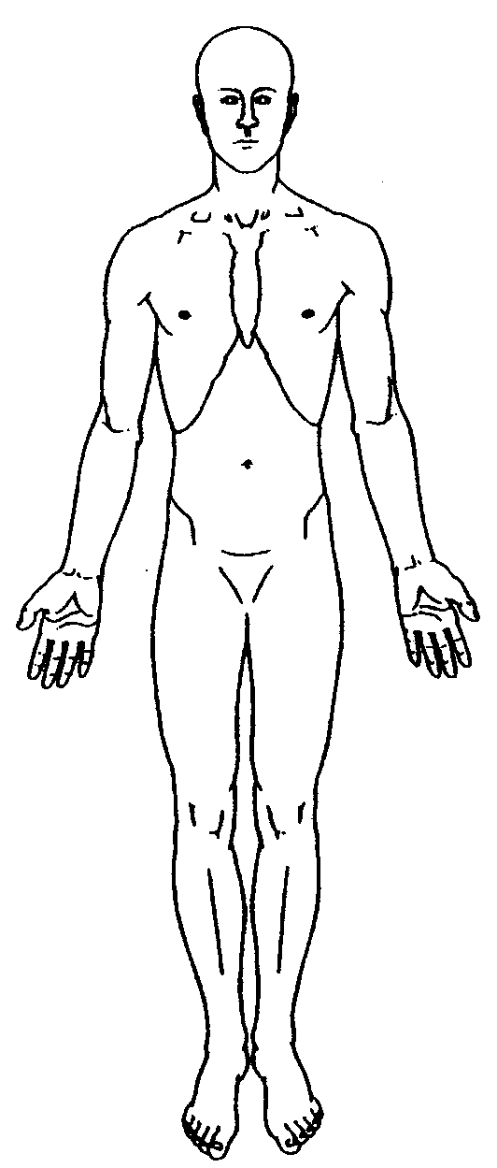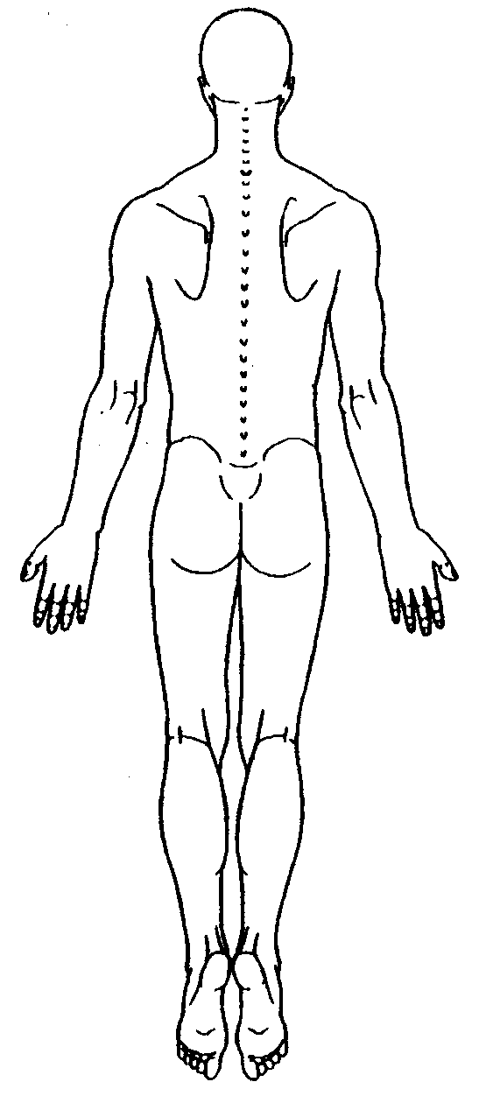

RATE YOUR PAIN (Please circle your rating)
0-3 = Mild 4-6 = Moderate 7-10 = Severe

1. Right now: 0 1 2 3 4 5 6 7 8 9 10
2. At best: 0 1 2 3 4 5 6 7 8 9 10
3. At worst: 0 1 2 3 4 5 6 7 8 9 10

4. What makes it better?_____________________________________________________

5. What makes it worse?______________________________________________________

PAGE 1 0F 3 New Patient Questionnaire

HAVE YOU HAD ANY OF THE FOLLOWING TESTS OR TREATMENTS FOR THIS PROBLEM?

TESTS: YES NO DATE

X-Rays ____ ____ ____________________________

MRI ____ ____ ____________________________

CT Scan ____ ____ ____________________________

Myelogram ____ ____ ____________________________

Bone Scan ____ ____ ____________________________

EMG ____ ____ ____________________________

TREATMENTS: YES NO DATE

Medication ____ ____ ____________________________

Injections ____ ____ ____________________________

Surgery ____ ____ ____________________________

Physical Therapy ____ ____ ____________________________

Other Tests or Treatments:________________________________________________________________________

PAST MEDICAL HISTORY:

List Medical Problems:____________________________________________________________________________

List Surgeries & Dates: ___________________________________________________________________________

List Any Medication Allergies:_______________________________________________________________________

List Medical Problems that Run in Your Family.

Mother____________________________Father_______________________Siblings______________________

Do you smoke or use tobacco products? (Please Circle) YES NO
If YES, how much/many per day?___________

Do you drink alcohol (beer, wine, etc.)? (Please Circle) YES NO
If YES, frequency/amount per day?________________

Are you or have you in the past used street drugs or been addicted to drugs? YES NO

Please Explain:_______________________________________________________________________

PAGE 2 0F 3 New Patient Questionnaire

REVIEW OF SYSTEMS Please choose symptoms you currently are experiencing & write comments as necessary:

Psychologic O None Renal O None
O Anxiety, Depression, or PTSD O Problems urinating
O Sleep problems O Bloody urine
O Anger problems O Difficulty controlling urination
O Attempted suicide or thoughts O Pain with urination
O Homicidal thoughts O Kidney problems

Neurologic O None
O Weakness O Loss of sensation
O Fatigue O Loss of muscle strength
O Loss of bowel or bladder control O Balance problems
O Muscle spasm or stiffness O Sound sensitive
O Light sensitive O Difficulty standing/walking
O Memory loss O Difficulty talking
O Numbness or tingling

Head/Eyes/Ears/Nose/Throat O None
O Headaches O Ringing in the ears
O Recent or past head injury O Dizziness
O Vision or hearing problems O Blindness
O Nose bleeds O Difficulty swallowing

Muscles O None Allergic/Immunologic O None
O Muscle pain O History of hepatitis
O Swelling of the joints O Chronic Active Hepatitis
O Muscle weakness O Anaphylactic/severe allergic reaction
O Muscle spasms or swelling O Frequent infections or fevers

Blood/Fluid O None Pulmonary O None
O Abnormal bleeding O Chronic cough or lung infections
O Anemia O Shortness of breath
O Generalized swelling O Wheezing
O History of blood clots O Sleep Apnea/CPAP/Home oxygen

Gastro-intestinal O None Cardiovascular O None
O Constipation O Chest pain
O Diarrhea O Swelling of hands or feet
O Nausea O Irregular heart beats
O Stomach bleeding O Hot or cold extremities
O Rectal bleeding O Tired with exertion
O Stomach pain O Skin changes
O Loss of bowel control O Poor circulation

GYN/Urologic O None Skin O None
O Post menopausal O Shingles history
O Early menopause (< age 45) O Skin rash or itching
O History of STD(s) O Changes in skin color or moles
O Vaginal/Penile discharge O Easy bruising
O Painful intercourse O Skin sensitivity
O Pain in genitalia O Changes to touch

Patient Signature:__________________________________ Date:_______________

Reviewed by Provider: _______________________________ Date: _______________
PAGE 3 0F 3 New Patient Questionnaire

MEDICATION LIST

ACROSS THE UNITED STATES, APPROXIMATELY 2.3 MILLION PEOPLE BECOME ILL OR HAVE ADVERSE SIDE EFFECTS FROM MEDICAL THERAPY EACH YEAR. ALSO, ADVERSE DRUG EVENTS ACCOUNT FOR ABOUT 4.7% OF US HOSPITAL ADMISSIONS AND CONTRIBUTE TO AN ESTIMATED $3.8 MILLION IN COSTS PER HOSPITAL EACH YEAR.

HERE AT IDAHO PHYSICAL MEDICINE AND REHABILITATION CLINICS AND AMBULATORY SURGERY CENTER, WE TAKE MEDICATION DELIVERY VERY SERIOUSLY. WE BELIEVE THAT YOU, THE PATIENT, ARE A KEY MEMBER OF THE TEAM THAT NEEDS TO BE INVOLVED IN ENHANCING ACCURATE AND COMPLETE LIST OF YOUR CURRENT MEDICATIONS. THIS WOULD INCLUDE THE NAME, DOSE, AND FREQUENCY OF EACH MEDICATION YOU TAKE. SINCE THIS INFORMATION IS DETAILED AND MAY BE DIFFICULT TO REMEMBER, WE ASK YOU TO BRING ALL CURRENT MEDICATION BOTTLES (INCLUDING MULTI-VITAMINS, HERBALS, SPECIAL CREAMS OR LOTIONS, LAXATIVES, AND ANY OTHER OVER-THE-COUNTER REMEDIES YOU TAKE) WITH YOU WHEN YOU COME FOR YOUR APPOINTMENT OR PROCEDURE. IF YOU ARE UNABLE TO BRING IN THE BOTTLES, PLEASE BRING IN AN UPDATED MEDICATION LIST INCLUDING ALL OF THE ABOVE INFORMATION. YOU ARE WELCOME TO USE THE TEMPLATE ON THE BACK OF THIS LETTER FOR THIS PURPOSE.

WHEN YOU ARRIVE AT THE CLINIC OR ASC, YOU WILL BE ASKED TO REVIEW THE INFORMATION WE HAVE REGARDING YOUR MEDICATION IN OUR MEDICAL RECORD AND TO EDIT IT BASED ON YOUR MEDICATION BOTTLES OR THE MEDICATION LIST THAT YOU BRING IN.

WHEN YOU LEAVE OUR FACILITY, WE WILL GIVE YOU AN UPDATED LIST OF YOUR MEDICATIONS FOR YOU TO TAKE TO YOUR NEXT PROVIDER OF CARE.

WE ARE DEDICATED TO PROVIDING THE HIGHEST QUALITY, SAFEST CARE POSSIBLE, AND WE APPRECIATE YOUR PARTNERSHIP TO SUPPORT US IN ACHIEVING THIS GOAL. PLEASE FEEL FREE TO CONTACT US AT (208) 884-1333 OR 489-4016.

SINCERELY,

The Providers at IPMR

IDAHO PHYSICAL MEDICINE AND REHABILITATION, PA/AMBULATORY SURGERY CENTER
MEDICATION LIST

Please complete and bring to each visit.

Pharmacy name and # ________________________________________________________

Patient Name:___________________________ Birth Date: _____________

Allergies: __________________________________________________________________

Please be accurate with medication names, dosages and how many times a day taken.

Medication or Supplement | Dose and Frequency
Example: Aspirin | 81 mg by mouth once a day
Initial of IPMR staff verifying medication

IPMR Financial Policy

INSURED
We participate in most major health plans. We have contracts with many HMO's, PPO's, insurance companies and government agencies including Medicare and Medicaid. Our business office will submit claims for any services rendered to a patient who is a member of one of these plans and will assist you in any way we reasonably can to help get your claims paid. It is the patient's responsibility to provide all necessary information before leaving the office. If you have a secondary insurance we will automatically file a claim with them as soon as the primary carrier has paid. Your insurance company may need you to supply certain information directly. It is your responsibility to comply with their request.

You must present your insurance card at the time of your appointment.

If you are insured by a plan we do business with but don't have an insurance card with you, payment in full for each visit is required until we can verify your coverage.

If you are a member of an insurance plan with which we do not participate, payment in full is due at the time of service

Non-Covered And Out Of Network Services:

Medical services that are considered by your insurance company to be non-covered, out of network, or not medically necessary will be your responsibility.

UNINSURED
If you do not have group or individual medical insurance, payment for all professional services is expected at the time of their visit. You will be eligible for a prompt pay discount as outlined in the IPMR Prompt Pay discount policy.

MOTOR VEHICLE ACCIDENTS (MVA)
IPMR will verify med pay on first party MVA claims and if available submit claims on your behalf until the first party claim exhausts. We do not do any third party billing, and all claims are considered to be your responsibility for payment in full. However, at your request, we will submit a claim to your primary health insurance carrier. You may receive an accident questionnaire from the insurance company to be completed and returned. If the questionnaire is not returned to your medical insurance company and/or we receive a denial on your claim, you will be responsible for payment in full.

WORKMAN’S COMPENSATION
It is your responsibility to provide our office staff with employer name, claim number, case worker and prior authorization if required. If the claim is denied by the workers' compensation insurance carrier, it then becomes your responsibility. At your request, we will submit the claim to your primary medical insurance carrier with a copy of the workers' compensation insurance denial. If your primary medical insurance carrier's claim is denied, you will be responsible for payment in full. Please note, we do not accept out of state workers compensation.

NONPAYMENT
All patient responsible balances that remain delinquent after 90 days, with no response to our requests for payment, may be referred to a collection agency. Please be aware that if a balance remains unpaid, you and/or your immediate family members may be discharged from this practice. If this is to occur, you will be notified by regular and certified mail that you have 30 days to find alternative medical care. During that 30-day period, our physician will only be able to treat you for emergent issues only.

Consent to Allow Family Member or Other Person Involved in Care or
Payment to Access Medical Information

Patient name: ______________________________________ Date of Birth: _____________________

1. I am either the patient identified above, or I am the personal representative of the patient with legal authority to make health care decisions for the patient.

- The person(s) listed below are family members or others who are involved in the patient’s health care or payment for healthcare. I give permission to Idaho Physical Medicine and Rehabilitation (“IPMR”) to disclose the patient’s protected health information to such persons.

[List names, relationship and phone numbers of persons]:

NAME | RELATIONSHIP | PHONE NUMBER

- In addition to the persons listed above, there are or may be other persons who are involved in the patient’s health care or payment for health care. This consent is not intended to limit IPMR’s authority to disclose protected health information to such other persons to the extent allowed by applicable law, including but not limited to 45 CFR 164.510.

Signature: ______________________________________ Date: ___________________

If signed by a Personal Representative:

Print name of Personal Representative

State authority of Personal Representative or relationship to patient.

